Batch: B2 Roll No.: 16010121200

Experiment / assignment / tutorial No. 2

TITLE: Project Metric estimates for Mini Project

AIM: To enable the students learn different techniques for performing software size and cost estimation
______________________________________________________________________
Expected Course outcome of Experiment:

CO 1: Understand the software development process and Estimate different types of resources for the given project.
_____________________________________________________________________
Books/ Journals/ Websites referred:

- Roger Pressman, “Software Engineering”, sixth edition, Tata McGraw Hill.
- http://sunset.usc.edu/csse/research/COCOMOII/cocomo_main.html
- http://sunset.usc.edu/research/COCOMOII/expert_cocomo/expert_cocomo2000.html
_____________________________________________________________________
Pre Lab/ Prior Concepts:

Software projects have a tendency of going past their deadline, going over budget, or both. The problem lies in the estimation of the amount of effort required for the development of a project. The cost estimation is usually dependent upon the size estimate of the project, which may use lines of code or function points as metrics. There are several different techniques for performing software cost estimation, including expert judgement and algorithmic models. Estimation by expert judgement is a common way of estimating the effort required for a project. Unfortunately, this method of estimation does not emphasize re-estimation during the project life cycle, which is an important part of project tracking, because it allows the estimates to be improved during the project life cycle. The quality of a cost estimation model is not so much attributed to the initial estimate, but rather the speed at which the estimates converge to the actual cost of the project. COCOMO is a popular algorithmic model for cost estimation whose cost factors can be tailored to the individual development environment, which is important for the accuracy of the cost estimates. More than one method of cost estimation should be done so that there is some comparison available for the estimates. This is especially important for unique projects. Cost estimation must be done more diligently throughout the project life cycle so that in the future there are fewer surprises and unforeseen delays in the release of a product.

Estimation of size and cost of the developing project is required for the following major decision situations
- Financial decisions involving a software development effort
- Setting project budgets and schedules as a basis for planning and control
- Deciding on or negotiating tradeoffs among software cost, schedule, functionality, performance or quality factors
- Making software cost and schedule risk management decisions
- Deciding which parts of a software system to develop, reuse, lease, or purchase
- Making legacy software inventory decisions: what parts to modify, phase out, outsource, etc
- Deciding how to implement a process improvement strategy, such as that provided in the SEI CMM
Defining Cost estimation:
Cost estimation can be defined as the approximate judgement of the costs for a project. Cost estimation will never be an exact science because there are too many variables involved in the calculation for a cost estimate, such as human, technical, environmental, and political. Furthermore, any process that involves a significant human factor can never be exact because humans are far too complex to be entirely predictable. Furthermore, software development for any fair-sized project will inevitably include a number of tasks that have complexities that are difficult to judge because of the complexity of software systems.
Cost estimation is usually measured in terms of effort. The most common metric used is person months or years (or man months or years). The effort is the amount of time for one person to work for a certain period of time. It is important that the specific characteristics of the development environment are taking into account when comparing the effort of two or more projects because no two development environments are the same. A clear example of differences in development environments are the amount of time people work in different countries; the typical workweek in North America is 40 hours per week, while in Europe the typical workweek is 35 hours per week. Thus, when comparing a project from North America with a project from Europe, a conversion factor would have to be used to all for an accurate comparison. Different variables can be used for cost estimation, which leads to a difficulty when comparing projects if standard models or tools are not used. For example, a cost estimate can include factors from management, development (e.g., training, quality assurance), and other areas specific to an organization.

Estimator:
The people who do the cost estimates could be either directly or indirectly responsible for the implementation for a project, such as a developer or manager, respectively. Someone who has knowledge of the organization and previous projects could use an analogy-based approach to compare the current project with previous projects, which is a common method of estimation for small organizations and small projects. The historical data is often limited to the memory of the estimator. In this case, the estimator would need to be experienced and would likely have been with the company for awhile.
Some people believe it is better if the estimates are done by outsiders so that there is less chance of bias. It is true that people outside an organization will likely have to deal with fewer company politics than people within the organization. For example, the developer for a company may want to please the manager and so give an estimate that is overly-optimistic. The disadvantage of having an outside estimate is that the person would have less knowledge of the development environment, especially if the person is from outside the company. An empirical method of estimation would then be required, such as the Constructive Cost Model (COCOMO. Empirical methods of estimation can be used by all types of estimators. There may be some resistance to using an empirical method of estimation because there may be some question on whether a model could outperform an expert. People who are accurate estimators are rare in our experience, and so it is best to get the opinion of several people or tools.
Cost estimation using different COCOMO models:
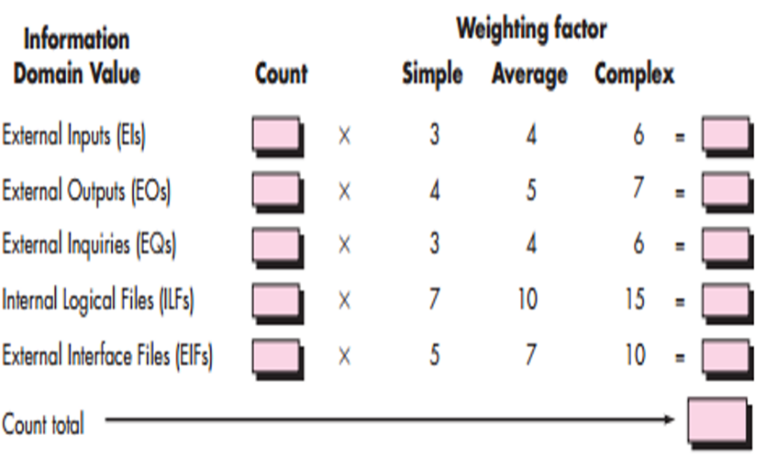

Step 1:
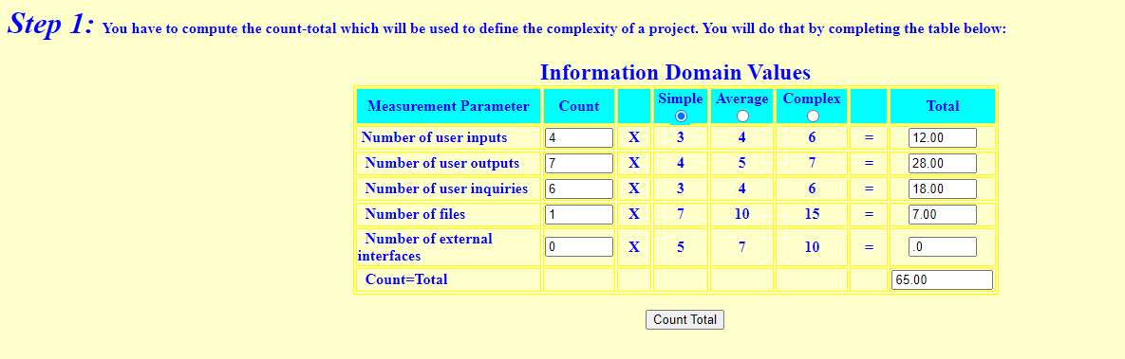

User inputs are the smallest unit of activity that is meaningful to the end user in the business. Primary purpose is to maintain one or more internal file and/or to alter the behaviour of the system.
User outputs are processes that generates data or control information sent outside the application’s boundary. Primary purpose is to present information to user through processing logic other than or in addition to the retrieval of data or control information.
User inquiries are made up of an input-output combination that results in data retrieval. Primary purpose is to present information to the user through the retrieval of data or control information.
Internal Files are a user identifiable group of logically related data or control information maintained within the application scope. Primary purpose is to hold data maintained through one or more elementary processes of the primary application being counted.
External Interfaces are a user identifiable group of logically related data or control information referenced by the application, but maintained within the scope of another application. Primary purpose is to hold data transferred through one or more elementary processes within the boundary of the application counted.

Step 2:
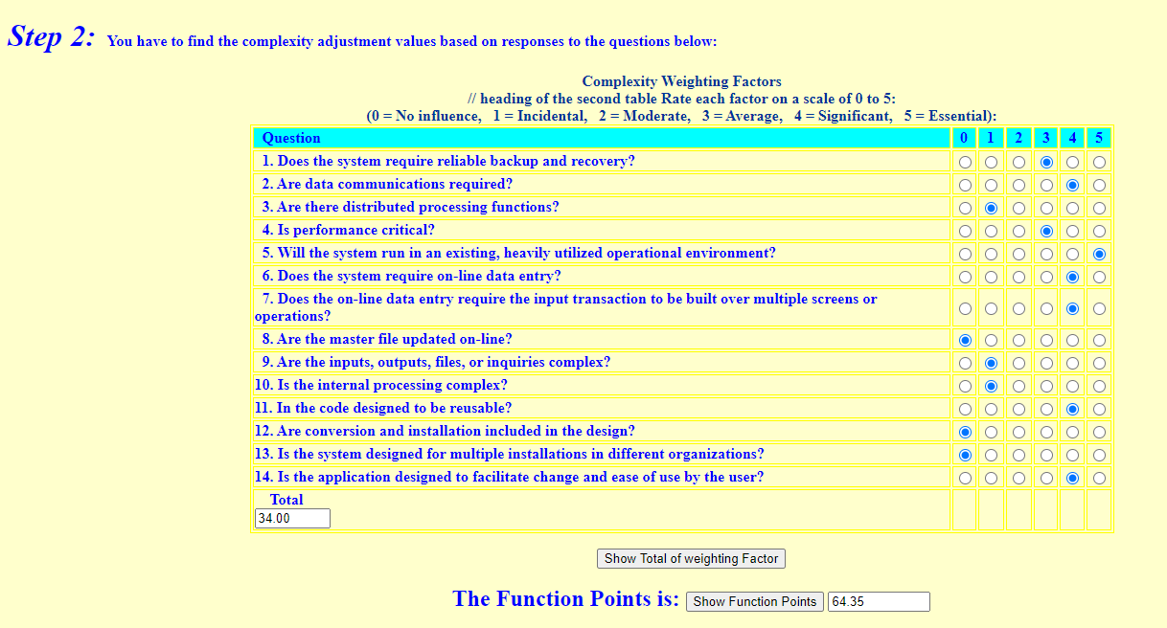

Step 3:
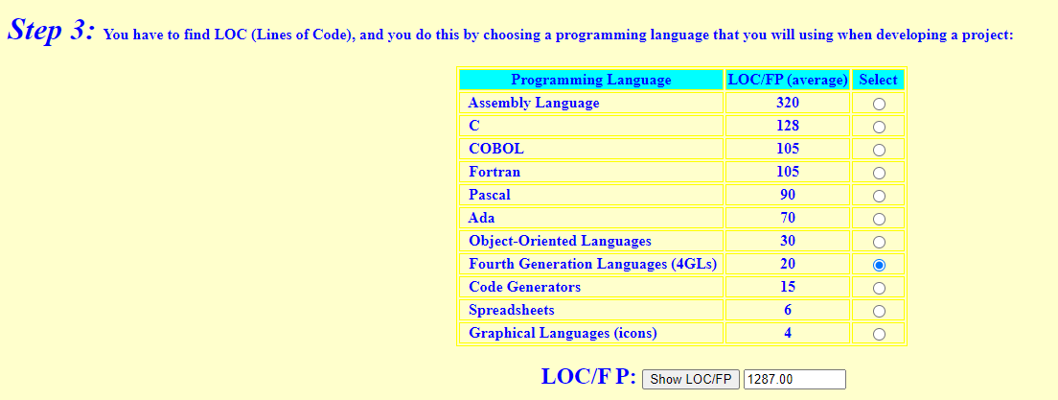
Step 4:
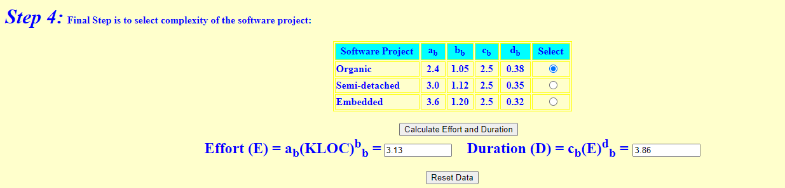

Conclusion:
In this experiment, the COCOMO model performed excellently for calculating project effort, duration, and staffing requirements. By accounting for factors including project size, complexity, and team experience, precise estimates were generated. A software project is said to be an organic type if the team size required is adequately small, the problem is well understood and has been solved in the past and also the team members have a nominal experience regarding the problem.

Post Lab Descriptive Questions
- You are appointed as an estimator to find out efforts required to implement the following project. The goal of the project is to create a database of all Hindi films released since 2000. The software would allow one to generate a list of top ten hit films, top ten flop films, best comedy films, and so on. Using your prior experience you have decided the approximate sizes of each module of the software as follows:
Data entry (0.9 KDSI)
Data update (0.7 KDSI)
Query (0.9 KDSI)
Report generation and display (2 KDSI)
Also take into consideration the following cost drivers with their ratings:

Storage constraints (Medium)
Experience in developing similar software (High)
Programming capabilities of the developers (Low)
Application of software engineering methods (High)
Use of software tools (Medium)
(All other cost drivers have nominal ratings).

Now answer the following:

Applying intermediate COCOMO estimate the minimum size of the team you would require to develop this system
Assuming that your client would pay Rs. 50,000 per month of development, how much would be the likely billing?
- Identify type of a project as per COCOMO
- Prepare an estimate of required effort and cost
Limitations: Values presented here are arbitrary and doesn't relate to real life

Ans:
To estimate the minimum size of the team required to develop the system and calculate the likely billing, we'll follow the steps of the Intermediate COCOMO model.

a) Identify the type of project as per COCOMO:
Since the project involves the development of a database and software to handle data entry, update, queries, and reporting functionalities, it falls under the category of an Organic project type in COCOMO. Organic projects are typically characterized by small teams, relatively straightforward requirements, and a well-understood development process.

b) Prepare an estimate of required effort and cost:

1. Calculate Total Adjusted Function Points (AFP):
AFP = Data entry + Data update + Query + Report generation and display
AFP = 0.9 + 0.7 + 0.9 + 2 = 4.5 KDSI (Kilo Delivered Source Instructions)

2. Calculate Size of Software (SS):
SS = AFP * (1 + sum of cost drivers)
Since the cost drivers have been assigned ratings, we'll sum up their ratings:
Sum of cost drivers = 2 (Storage constraints) + 3 (Experience) + 1 (Programming capabilities) + 3 (Application of software engineering methods) + 2 (Use of software tools) = 11
SS = 4.5 * (1 + 11) = 4.5 * 12 = 54 KDSI

3. Calculate Effort (E) in person-months:

E = a * (SS^b)
For Organic projects, a = 2.4 and b = 1.05 (constants from COCOMO model)
E = 2.4 * (54^1.05) ≈ 163.36 person-months

4. Calculate Development Time (D) in months:
D = c * (E^d)
For Organic projects, c = 3 and d = 0.38 (constants from COCOMO model)
D = 3 * (163.36^0.38) ≈ 9.54 months

5. Calculate the Required Team Size (N):
Calculate the Required Team Size (N):
N = E / D
N = 163.36 / 9.54 ≈ 17.13
Since you can't have a fraction of a team member, you would likely need a team of around 18 people to develop this system within approximately 9.54 months.
6. Calculate Likely Billing:
Given that the client would pay Rs. 50,000 per month of development, the likely billing would be:
Likely billing = Development Time * Monthly Payment

Likely billing = 9.54 * Rs. 50,000 ≈ Rs. 4,77,000

- Explain COCOMO II model.

COCOMO II, which stands for Constructive Cost Model II, is an enhanced version of the original COCOMO model. It's a software cost estimation model designed to provide more accurate and detailed estimates for software project planning and management. COCOMO II takes into account various factors that impact the cost, effort, and schedule of software development projects, providing a systematic way to analyze and predict these aspects.
References to this model typically call it COCOMO 81. In 1997 COCOMO II was developed and finally published in 2000. COCOMO II is the successor of COCOMO 81 and is better suited for estimating modern software development projects. It provides more support for modern software development processes and an updated project database.
COCOMO II is tuned to modern software life cycles. The original COCOMO model has been very successful, but it doesn't apply to newer software development practices as well as it does to traditional practices. COCOMO II targets modern software projects, and will continue to evolve over the next few years.

The following are the various COCOMO submodels:
Application Composition Model (COCOMO II-ACM): This submodel is used during the earliest stages of project planning when only limited information about the project is available. It estimates project size based on lines of code or function points and employs a set of scaling factors to derive a preliminary estimate of effort and schedule.

Early Design Model (COCOMO II-EDM): As the project advances and more details become available, the Early Design Model comes into play. It considers characteristics such as the software architecture, development process, and the team's experience. This submodel provides a more refined estimate by factoring in these details.

Post-Architecture Model (COCOMO II-Post-Arch): Once the software architecture is established, this submodel is used to provide even more detailed estimates. It takes into account factors like reuse of existing components, team experience, project constraints, and additional cost drivers that influence the project's complexity and resource requirements.

COCOMO II works by using mathematical formulas that combine the size of the project, the chosen submodel, and the values of the effort multipliers. The result is an estimation of effort (measured in person-months), schedule (in months), and cost (in terms of resources and finances) required to complete the project.

